**Output:**

1. Trace Route command

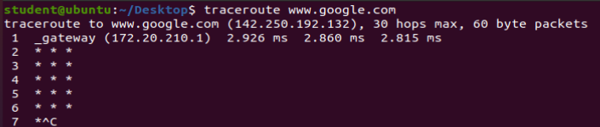

2. w and who command

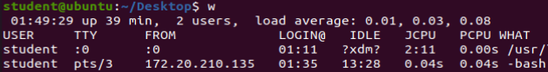

3. whois command

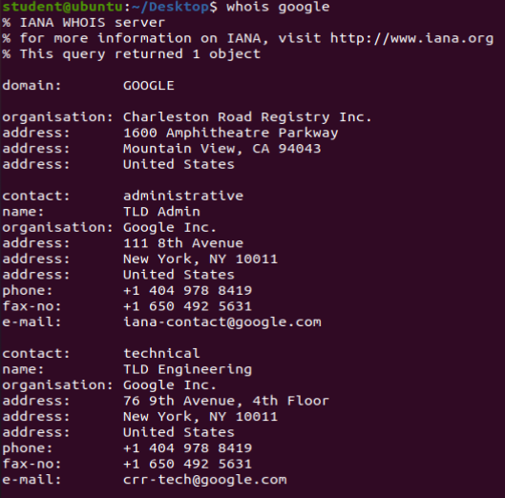

4. netstat commands

4a. netstat -a

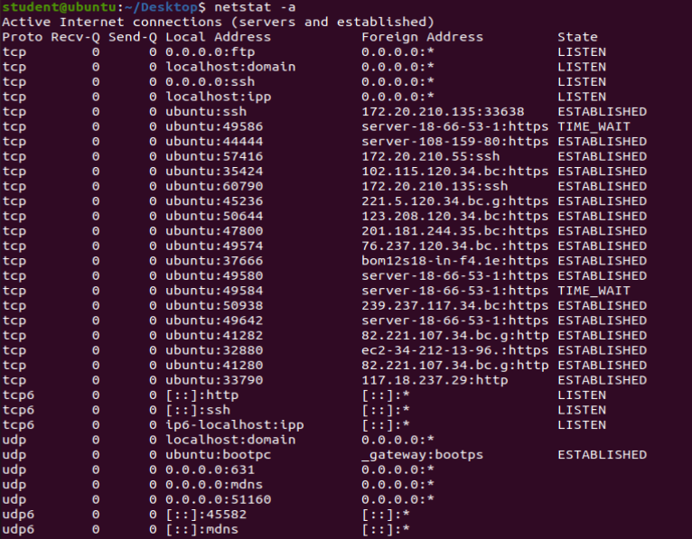

4b. netstat -l

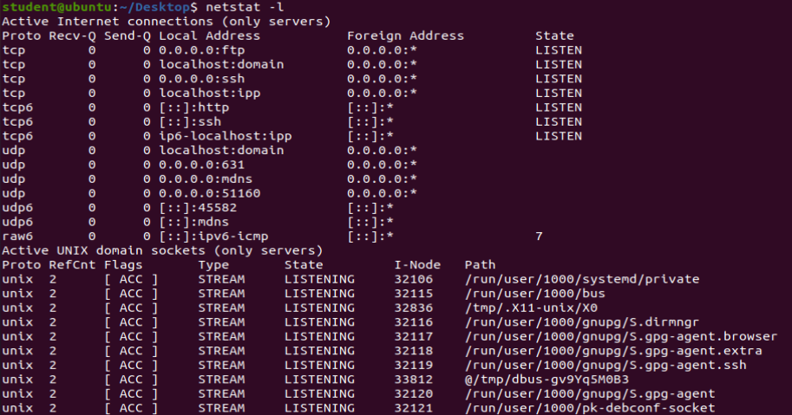

4c. netstat -s

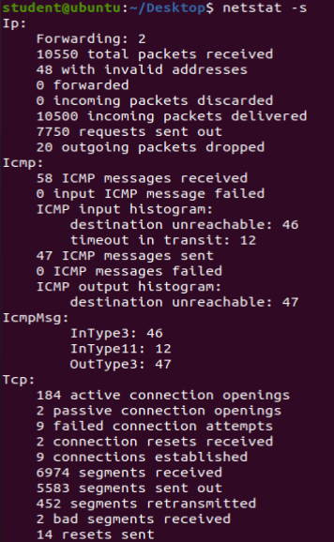

4d. netstat -au

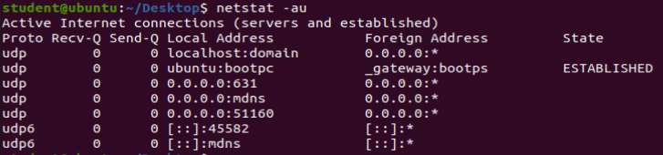

5. ifconfig command

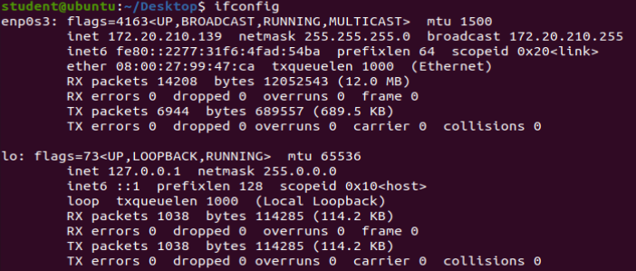

6. nslookup command

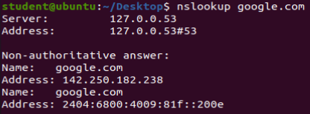

7. dig command

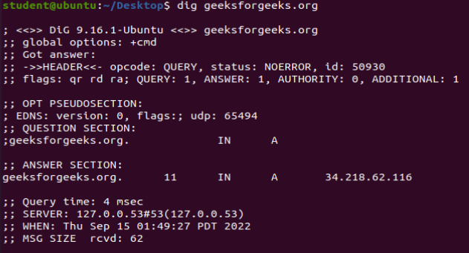

8. pstree -na

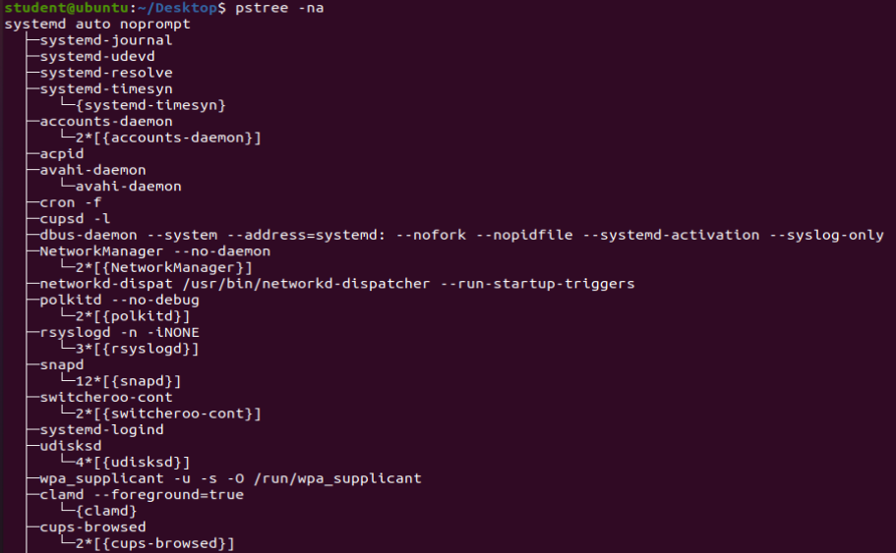

9. ls command

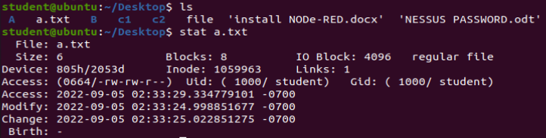

10. stat file_name command

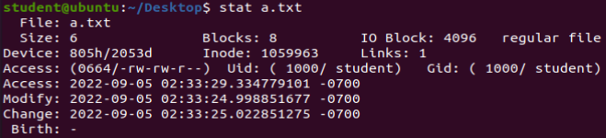

11. Command - Cat /var/log/auth.log

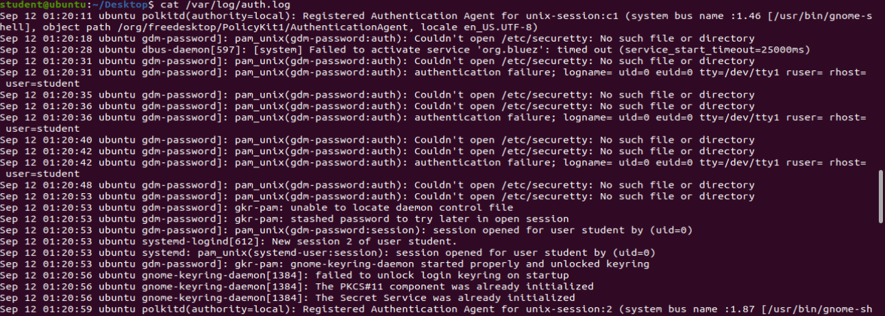

12. Connecting to another system through SSH

Command : ssh username@ip_address

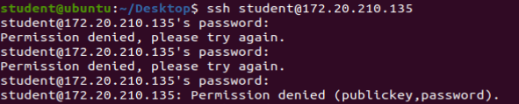

3 wrong password attempts, permission denied

Correct password attempt

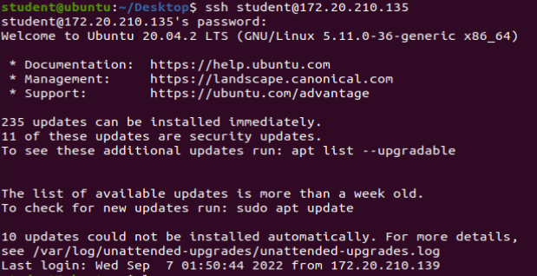

Connection successful

Viewing files and directories of connected user



Creating new files

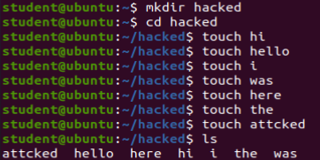

Now,

Checking

Q1.Who entered the system?

When he entered the system?

What is the time period he stayed in my machine?

Answer: Use w command



Who - student

When - 1.17

Time period he stayed - 1s

Q2. How he entered into my system

Command: cat /var/log/auth.log | grep ip_address

